Feasibility Analysis

**Description about the application:**

Ours is a “One to many” file sharing application. The purpose of the application is to make one to many file sharing easy and secured. When user upload a file it gets uploaded into cloud and generate a key. The sharing can be done only if you have the key. The file sharing is done without asking any user information. So, it’s helpful for user who don’t want to share any of his information. There will be 2 type of user in this. Uploaders and downloaders. Same person can be both. This is how our application works.

**Survey:**

The following is the pie chart of the responses for the feasibility of our “one to many ” file sharing application.

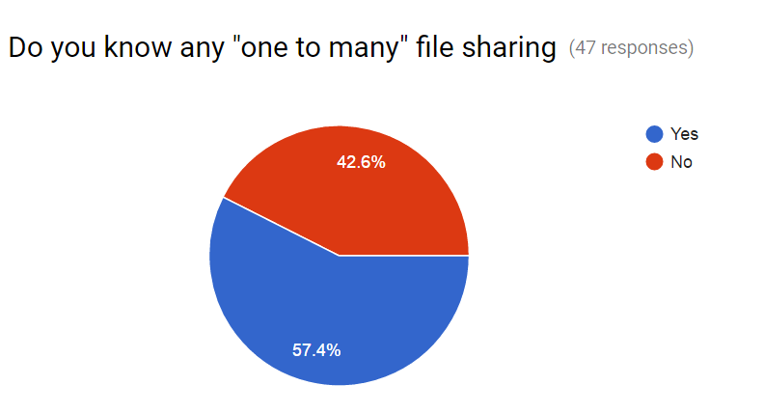

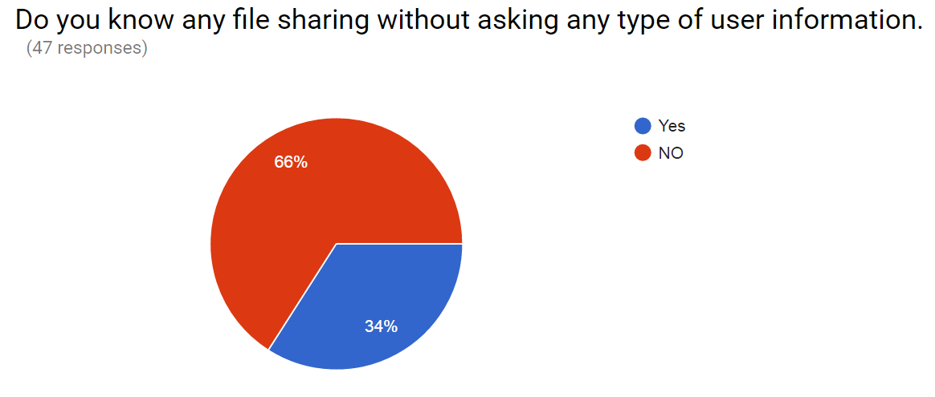

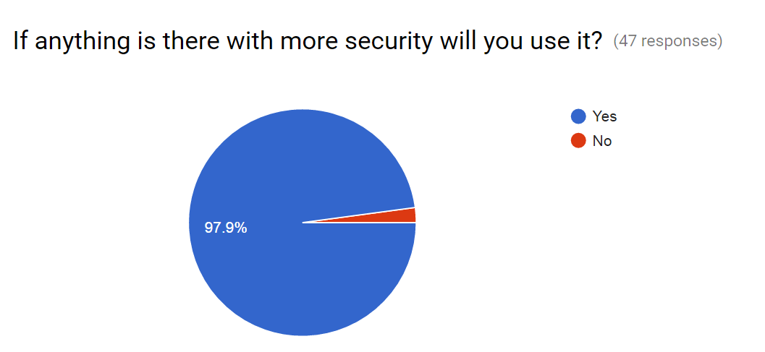

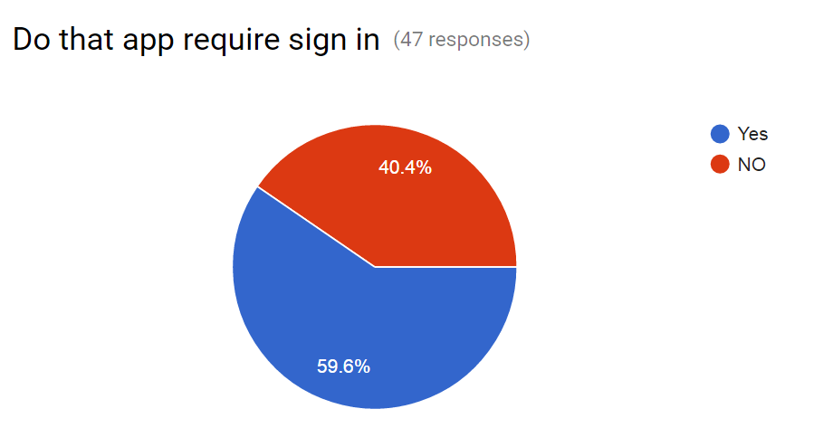

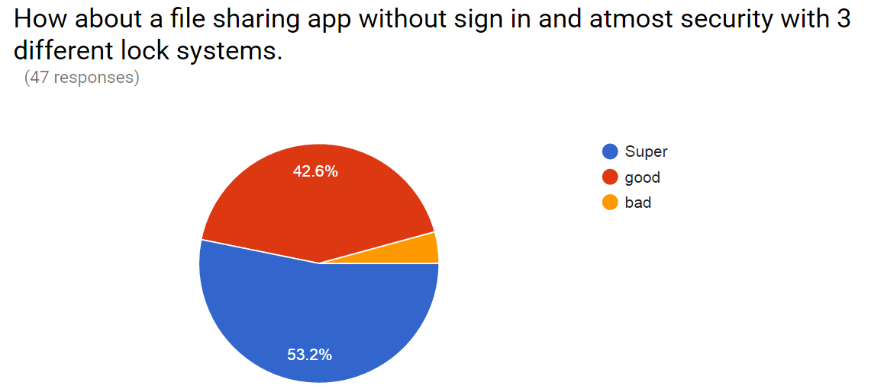

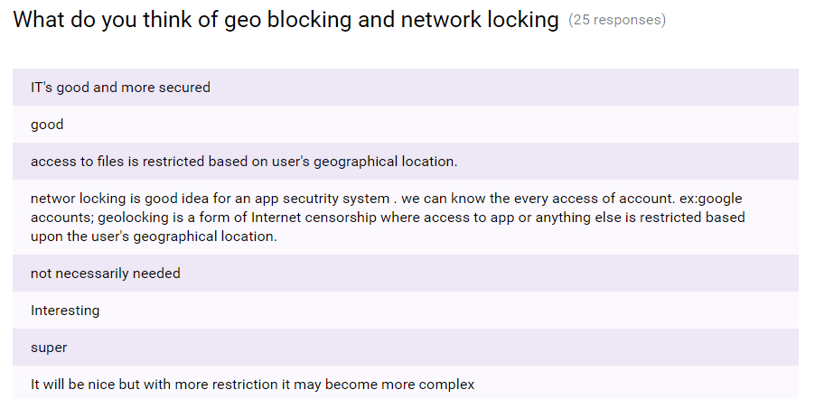

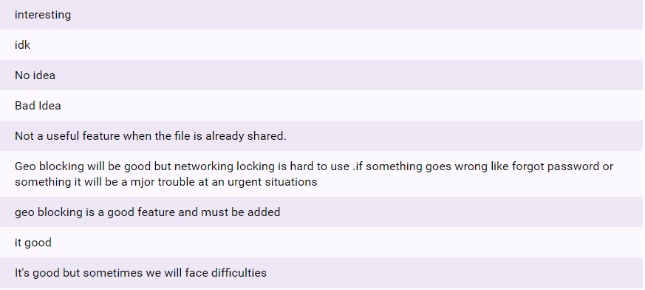

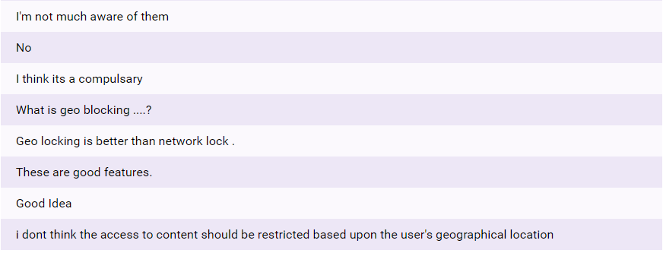

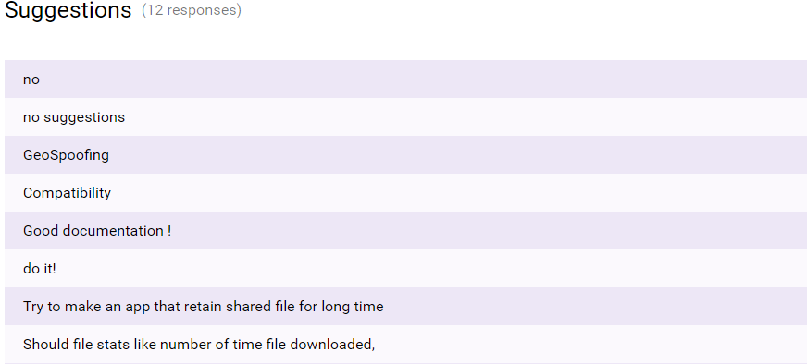

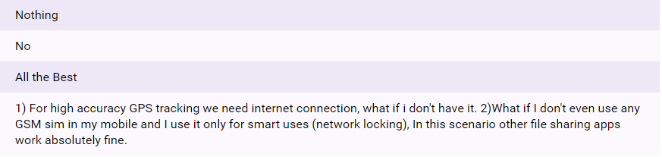

The above are the suggestions for “One to many” file sharing application. The study also resulted that the proposed system can contribute organisational objectives and can be done with in the present technology and budget.

**Some of the questions for people in Organisation which helps in the study of the system feasibility are as follows:**

**What are current process problems?**

Even though there are many file sharing but most of them are only “one to one” sharing. By chance if there is any “one to many” it requires user’s information (email id or user name etc) for accessing. So, here the problem arises when the user doesn’t want to share his personal information.

**How will the proposed system help?**

To overcome the above problem, we came up with a new idea of no sign is required. By this, there is no need of user/client’s information.

**Is new technology needed? What skills?**

Here there is need of GEO lock and Network lock. GPS is required for Geo lock to track the user’s location. In case of Network lock, it requires SSID of that particular network.

**Recommendation:**

From above all reviews it shows that the application is feasible. And also recommendable.